Dear Parents and Carers,
Welcome back after the half term break. We have parents evenings on Monday and Thursday this week, and Monday next week. Please wear a mask for these meetings and keep at least 2m from other parents and staff at all times. Arrivals should be no more than 10 minutes before your appointment please.

Families in Need at Christmas
The staff and parents would like to put together some Christmas hampers to give to families who will really struggle to pay for Christmas this year. Please contact Mr Salisbury directly and in complete confidence if you would like to be considered for a hamper this year. No one else will know who they are given to.

Cooking fortnight
Thank you to everyone who helped to make our cooking fortnight a great success. Children showed great skills and enthusiasm for cooking, staff organised, demonstrated and washed up, and parents provided ingredients and helped with some of the cooking. Special thanks to Clive Harris for coming to demonstrate how to make a minestrone soup with Year 1, having Year 5 at Shaftesbury School to learn how to make Fajitas, and baking a delicious cake for Year 2! Massive thanks also to Mrs Brown’s son Jack, who brought his pizza van down from Bristol for the day so that Y6 could make pizzas.
The story of the Abbey Bake Off on Dress as a Chef Day was featured on This is Alfred last Saturday, and was in the Blackmore Vale Magazine this week. Congratulations to the six brave members of staff who took part, the judges declared them all joint winners.

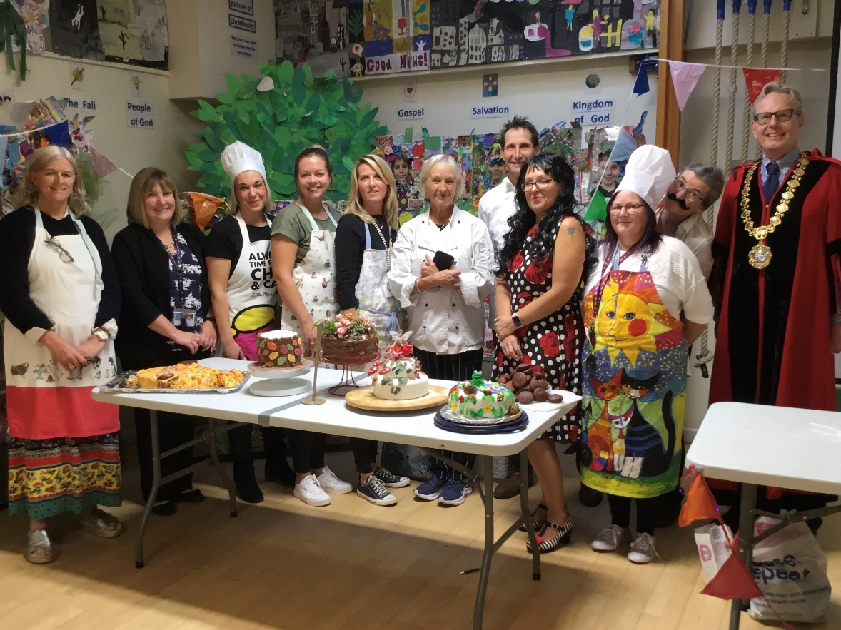
Cake sale success
Some of our Year 6 children held a very tasty cake sale on the last Friday before half term. They raised a fabulous total of £69.63 for the donkey sanctuary.

Poppies
Poppies will be on sale from Wednesday 3rd November at the start and end of the day. We also have an array of poppy related items such as wristbands, snap bands and badges which are always really popular!

Children in Need – Friday 19th November – PJs, fancy dress or bright colours for a donation of £1 or more.
Please note the date, we’ll take part in the special Joe Wicks workout and have one of our lunchtime discos if the weather allows it.

Transport survey
Dorset Council have asked for parents to share their views on transport to school issues. We are hoping to get them to provide a school crossing patrol outside our school, your support for this on the survey would be very useful.

To start the survey click here:

The survey closes on Friday 12th November 2021.

Inset Day change and Additional staff day.
We have started to work closely with four other primary schools in a collaboration called the Stour Vale Collaboration. The schools are Wyke Primary in Gillingham, St Gregory’s in Marnhull, Stower Provost Primary and St George’s in Bourton. In order to run training together with these schools, we need to change an INSET day from Monday 25th April to Friday 8th April 2022.
Due to the Queen’s platinum Jubilee, schools have been asked to put in an additional Inset Day this year. Ours will be on Monday 14th March 2022.

Art Days – Year 6 this Friday
Over the Autumn Term, classes from Y1-6 are taking turns to have a special Art Day. This week it is the turn of Y6 children. The children in the class taking part should wear non uniform for the day, clothes that they don’t mind getting a bit of water-based paint on.

Items we need to collect are:
- Colour magazines with garden or nature photos
- Wrapping paper with flowers or trees
- Broken or unwanted jewellery
- Floral fabrics including unwanted flowery clothes
- Old Birthday cards
- Anything shiny or glittery that can be cut up by the children.
Please send in anything you have from this list for a collection in your child’s classroom.

Michael Salisbury, Head teacher

September 2021 to August 2022

Autumn Term
Autumn half term | Monday 25 October 2021 to Friday 29 October 2021
Autumn term ends | Friday 17 December 2021
Christmas holidays | Monday 20 December 2021 to Monday 3 January 2022

Spring Term
INSET DAY | Tuesday 4 January 2022
Children start back | Wednesday 5 January 2022
Spring half term  INSET DAY | Monday 21 February 2022 to Friday 25 February 2022  Monday 14th March 2022
Spring term ends  INSET DAY | Thursday 7 April 2022  Friday 8th April 2022
Easter holidays | Monday 11 April 2022 to Friday 22 April 2022

Summer Term
Children start back | Monday 25 April 2022
Bank Holiday | Monday 2 May 2022 (May Day Bank Holiday)
Summer half term | Monday 30 May 2022 to Friday 3 June 2022
INSET DAY | Monday 6 June 2022
Summer term ends | Friday 22 July 2022
Summer holidays | Monday 25 July 2022 to Wednesday 31 August 2022

