Parenting Skills & Strategies Sessions Workshops Summer Term 2022 9.30-12noon
May 23rd2022 Sherborne Children Centre
May 24TH2022 St Mary’s The Virgin School Gillingham
June 21st2022 Blandford Children Centre

These sessions are intended for Adult Discussion only.
For further information and to book please contact the North Locality on
01258 474036 or email us at northlocality@dorsetcouncil.gov.uk 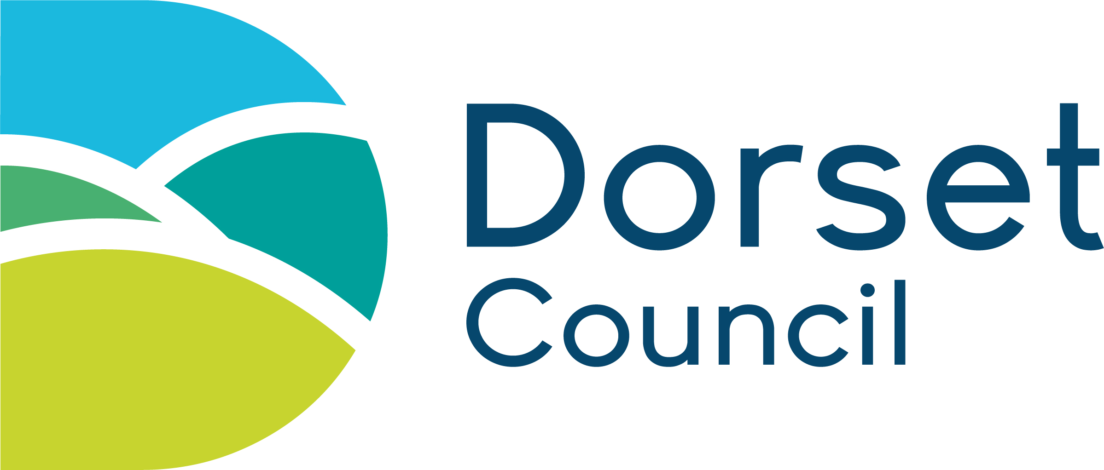

What are Parenting Skills & Strategies Sessions?
These sessions offer practical positive behaviour skills and strategies in an informal way, parenting is the possibly the hardest job your ever have!

They are based on the principles of well researched parenting programmes.
We cover impulsive, inattentive, and hyperactive children but we are not ASC specific. These workshops are for Parents/cares of children with challenging behaviours ages 3yrs-10yrs

